General Phone Photography Tips

Step One: Change photo quality in Settings
When using photos on websites or for print publications, high-quality photos perform best. Most people have their settings set to High Efficiency, which saves space but outputs a lower quality photo. We recommend switching this setting before taking photos that you might want to be considered for the calendar. Here’s how:
- Open the Settings app on your iPhone.
- Scroll down and tap Camera.
- Tap Formats.
- Under Camera Capture, select Most Compatible for JPEG/H.264
Note: Most Android phones will automatically shoot in JPEG and you do not need to update anything.

Step Two: Turn off the “Live Photo” feature
iPhone
Live photos take up more space and use more of your phone’s battery. They also reduce the quality of the final photo taken, so we recommend turning this feature off before taking photos for Blue Thumb.
- Open the Camera app
- Look at the top of the screen for the Live Photo icon (concentric circles)
- Tap the Live Photo icon once
- The icon will have a line through it, indicating Live Photos are OFF

Android
- Open the Camera app
- Look at the top of the screen for the Motion Photo icon (square play button)
- Tap the Motion Photo icon once
- The icon will have a line through it, indicating Motion Photos are OFF

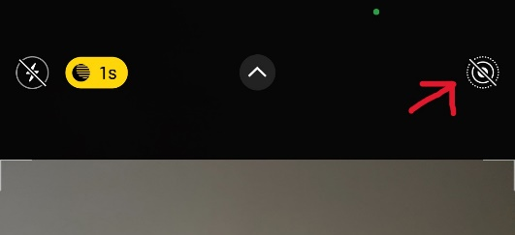
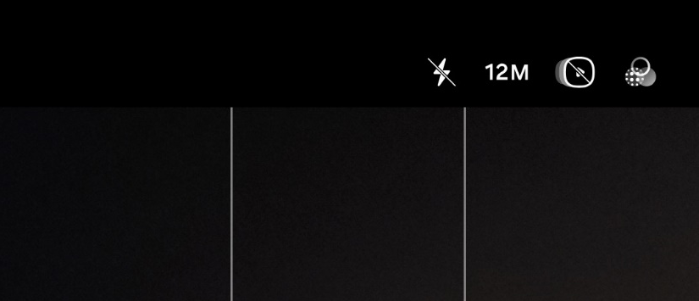

Step Three: Adjust Exposure
In the camera app, tap the screen and use the slider up and down to adjust the exposure. You can lock the focus on your subject by tapping and holding, then adjusting the exposure. Time of day will also affect your photo’s lighting. Direct midday lighting can cause harsh shadows and overexposed subjects, so try focusing on photographing objects in the shade or using the tips above to adjust your lighting.
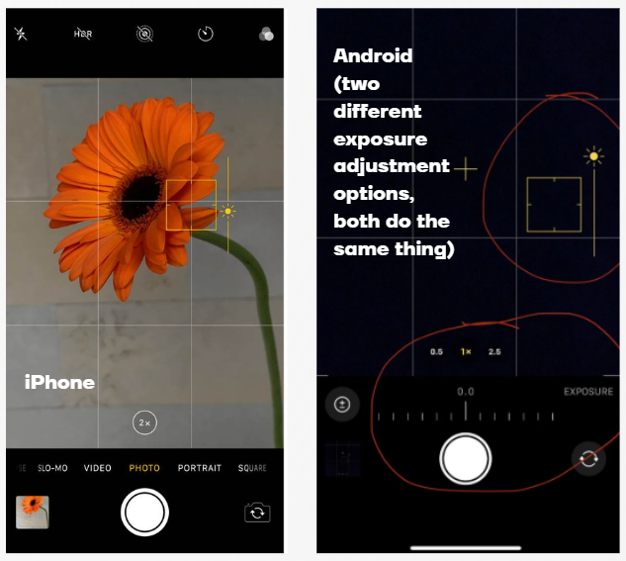
Step Four: Zoom with your feet
Most smartphones come with multiple lenses built in, and it can be tempting to zoom in with your fingers or picking one of the zoom lenses, but these options quickly decrease the quality of your photos.
Instead, try getting physically closer to your subject and taking a photo with your 1x lens when possible.

Step Five: Set up grid lines
iPhone
  - Open up Settings
  - Scroll down and tap on Camera
  - Toggle grid ON
  - When you open up your camera, you should now see faint 3x3 grid lines
Android
- Open up Settings
- Open Camera
- Tap on Camera Settings
- Scroll down and toggle on Composition Guide
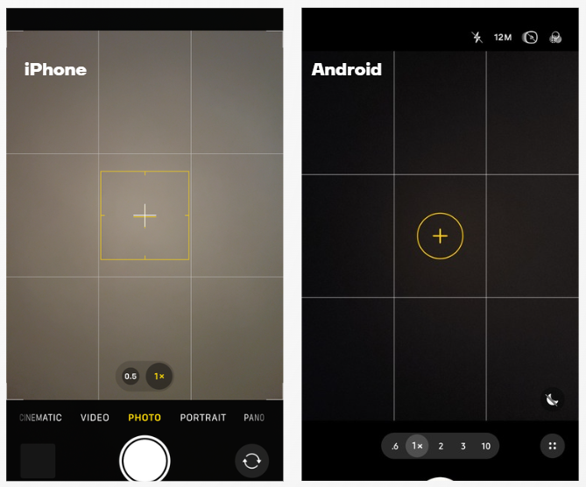

Step Six: Photos of children
Unless you have express permission to photograph, either through school’s photo permission form or directly from a parent, only take photos of backs of heads. If you have permission, feel free to get photos of their smiling faces. If any kids are shy or don’t want their photo taken, respect their wishes and avoid taking their photo. Be aware of children’s clothing/swimsuits and be mindful of what you’re taking photos of. Review photos of children carefully before submitting them or posting them online to ensure they are being well represented.

Step Seven: Wipe your lens before taking a photo!
Our fingers/hands leave a lot of oils and residues that can stick to our phone’s camera lenses when we take our phones out of our pocket/bags — especially if we’re outside and have sunscreen on! So, give your lens a quick wipe with a cloth or t-shirt before taking a photo.

Step Eight: Experiment with angles
Try shooting from different angles to make your photos more visually interesting. For example, try shooting from a low angle to make your subject appear larger or from a high angle to capture a unique perspective.

Step Nine: Use the rule of thirds
When framing a shot, imagine the frame divided into thirds both horizontally and vertically. Place your subject on one of the intersecting lines to create a more interesting and dynamic composition.

Step Ten: Try to avoid 0.5 photos when possible
We understand wanting to show more of the beautiful Oklahoma scene you’re photographing, but unfortunately, 0.5 photos can look distorted when used on a large scale or when printed. This is especially important when taking photos of people, as we don’t want to warp any of our friends!

Step Eleven: Take your photos!
We appreciate any photos you take while teaching or at events. We hope this guide has been helpful. If you have any other questions about photography or using your phone’s camera settings, please email justine.anderson@conservation.ok.gov

